

National University of Singapore

**IS4302: Blockchain and Distributed Ledger Technologies**

**Group Project**

**Bet5050**

**Architecture and Design Document**

**Team 9**

| **Team members:** | **Matriculation Number:** |
| --- | --- |
|  |  |
|  |  |
|  |  |
|  |  |
|  |  |
|  |  |

Table of Contents

**1. Introduction** **3**

1.1 Why do we want this system? 3

1.2 Problems with legacy sports betting 3

1.3 Our Idea and its Benefits 3

1.4 Information structures 4

1.5 Market dynamics 5

1.6 Limitations 6

1.7 Oracle 6

**2. Architecture** **8**

2.1 UML Diagram 8

2.2 Elaboration of how the system works 10

**3. Analysis** **14**

3.1 Desirable features 14

3.2 Bet5050 features 16

3.3 Building towards desirable features 17

3.4 Future 19

# 

# **1. Introduction**

## **1.1 Why do we want this system?**

The sports betting industry grew by 21% in 2021, and is expected to continue growing by 10% annually to 2025. This is likely driven by the penetration of connected devices and other growing digital infrastructure. In this report, we will discuss the current problems with legacy sports betting, and how we believe our blockchain driven solution can help to resolve these problems.

## **1.2 Problems with legacy sports betting**

The sports betting industry has raised concerns about fairness and transparency with legacy sports betting models. They are often unfair in that they often make profits either through hidden fees or by unfavorable odds, and profiting at the margins. They are also uncertain in that we cannot completely verify the authenticity of the platform, nor can we guarantee a payout or dispute bets in a fair manner.

## **1.3 Our Idea and its Benefits**

Our solution aims to resolve this problem with the use of smart contracts in our own dApp (Decentralized Application).

Our GitHub repository can be found here: <https://github.com/Ddaize/Bet5050>

The smart contracts will need a source of reliable real-world data to settle user-created betting markets. Importantly, the decentralized application will be dependent on Oracles.

***1.3.1 Immutability***

Immutability of the blockchain would allow for concrete betting practices where both the house and the user would have to comply with the results of a bet and prevent either party from pulling out in case of an adverse bet outcome.

All funds pooled for a particular bet are held in escrow, and will be paid out immediately upon game outcome.

***1.3.2 Transparency***

Smart contracts would ensure the transparency of all available bets online, such that no user is subjected to different odds compared to another user for the same bet, which in turn also adds to the safety of the bets. This will also prevent hidden fees levied by the broker.

***1.3.3 Stakeholder’s incentive***

Using the blockchain for online betting would allow both the user and the betting site to explore safer, quicker and more accessible bets. The most obvious advantage of this would be that payouts will not be able to be reverted, protecting the house from fraudulent payments or betting accounts, and the user from scams.

***1.3.4 Security***

Having funds and bets stored on smart contracts make the application more resilient to malicious attacks. The decentralized nature of our application also ensures that it cannot be compromised by a single point of failure.

***1.3.5 Accessibility***

Most legacy sports betting websites have very limited availability to specific regions, often due to regulatory requirements which differ greatly between countries or districts. Our application will be available to everyone.

***1.3.6 Anonymity***

Users will not be required to complete any KYC and will not need to disclose any personal information or payment information besides a wallet address to participate.

## **1.4 Information structures**

The table below summarizes the information structure of legacy sports betting against our proposal, Bet5050.

| **Information** | **Legacy** | **Bet5050** |
| --- | --- | --- |
| Publicly available historical information on games, e.g. how all teams performed in previous competitions | Common Knowledge | Common Knowledge |
| Published odds | Bookmaker | Common Knowledge |
| Participant’s own bets, e.g. amount wagered and on what odds | Better and Bookmaker | Common Knowledge |
| Other participants’ bets placed with bookmaker | Bookmaker | Common Knowledge |
| Bets placed with other betting pools | Bookmaker | Common Knowledge |

Common Knowledge with both Legacy Sports Betting and Bet5050

* For both legacy and Bet5050, every participant in the market has access to publicly available historical information on games or teams, e.g. how all teams performed in previous competitions, the players in each team, etc., that can be used to guide their calculation of odds

Common Knowledge only with Bet5050

* Common Knowledge with Bet5050 with regards to the true odds of any particular bet based on weightages of current bets, while odds with legacy betting are often not reflective of the true odds are manipulated to benefit the Bookmaker
* Number of bets placed
* Total amount wagered and on what odds
* Personal assessment/beliefs of how each team will perform
* Information on total amount willing to bet and what odds he/she is willing to accept

There exists information asymmetry within the legacy sports betting market. In legacy sports betting, Bookmakers have an unfair advantage with regards to information flows since they are able to see all bets wagered with them which allows them to generate more favorable odds; They can better monitor market (betters and other bookmakers) expectations on the outcome of the game and adjust their odds accordingly.

Participants are bound by unfavorable odds, and even though they are able to pick between different bookmakers to find more favorable odds, they are still likely to be unfavorable in comparison to odds generated in a decentralized marketplace like in Bet5050.

## **1.5 Market dynamics**

**1.5.1 Fairer Competition**

Currently, there is a great benefit to the bookmakers of having betting information in legacy sports betting kept private. It allows the bookmakers to capitalize on that information to generate odds that are favorable to themselves. However, with Bet5050, this unfair advantage on legacy exchanges can be washed out since our betting data is all public. Other betters and bookmakers can see the value weighted odds from our application which would set the benchmark for what the true odds should be and drive betters away from many legacy bookmakers, this would increase competition between bookmakers and force them to provide more favorable odds.

**1.5.2 Arbitrage**

Since the odds of our bets are value weighted, it is likely to differ drastically from other legacy bookmakers. This provides an opportunity for betters to take advantage of arbitrage by leveraging on different odds between the platforms and simultaneously placing bets with both Bet5050 and the legacy bookmaker. This arbitrage would negatively affect the bottom line of legacy bookmakers and push many less capable bookmakers out of the market.

## **1.6 Limitations**

***1.6.1 Security***

Although the aforementioned security risks of legacy sports betting can be resolved by our dApp, other new blockchain specific security concerns such as re-entrancy attacks may arise.

***1.6.2 Ethics***

As with anything related to betting, it has certain negative undertones. This project may be controversial because we are developing an application that may be enabling of gambling behavior. In particular, by making it so easy for people to access sports betting, we may be fuelling the gambling tendencies of vulnerable people, leading to an influx of gambling addiction.

Our team has several arguments against this. Firstly, betting is an inherent human behavior. Our application aims to cater to the market that is proactively aware of his/her risk appetite and has the disposable income to supplement their betting. Secondly, outside of discretionary betting decisions, we want to provide the most reliable information for people to make their decisions. For instance, one of our functions enables bettors to attain historical matches so that they can make more informed decisions of betting on upcoming matches. Most importantly, we want to cut out the unnecessary middle-man, who very often, are the very source of misinformation and unfair bets.

## **1.7 Oracle**

As smart contracts cannot access data outside the blockchain, we need Oracles to query, verify and authenticate external game data and relay it to the smart contracts.

We are mindful of the Oracle problem: The security, authenticity, and trust conflict between third-party Oracles and the trustless execution of smart contracts. However our focus in this project is not to evaluate the trust and centralization of Oracles, but rather to examine the benefits of Bet5050 as outlined above over legacy sports betting, and evaluate its efficacy.

Furthermore, unlike examples covered in the first Writing Assignment such as the academic transcript system where the information required is private and not something that can be accurately determined in the present (i.e. grades of a student are private between the institution and student and classes may have been graded many years ago); The nature of the data we are retrieving from the Oracles (i.e. football game scores, first goalscorer) is not subjective but instead deals in fact. The outcomes of a game are publicly available in real-time, objective, non-explanatory and well understood by everyone watching the game. There are also no fluctuations in the data between different sources for game outcomes. (i.e. unlike prices of certain assets, which may differ between exchanges)

As such, the Oracle problem is unlikely to pose any significant issue for our solution. A decentralized Oracle system utilizing multiple data sources, with submitters, voters and certifiers would be ideal. For our purposes of showcasing our solution, we have opted to create a simple oracle for ease of testing and illustration.

# **2. Architecture**

## **2.1 UML Diagram**

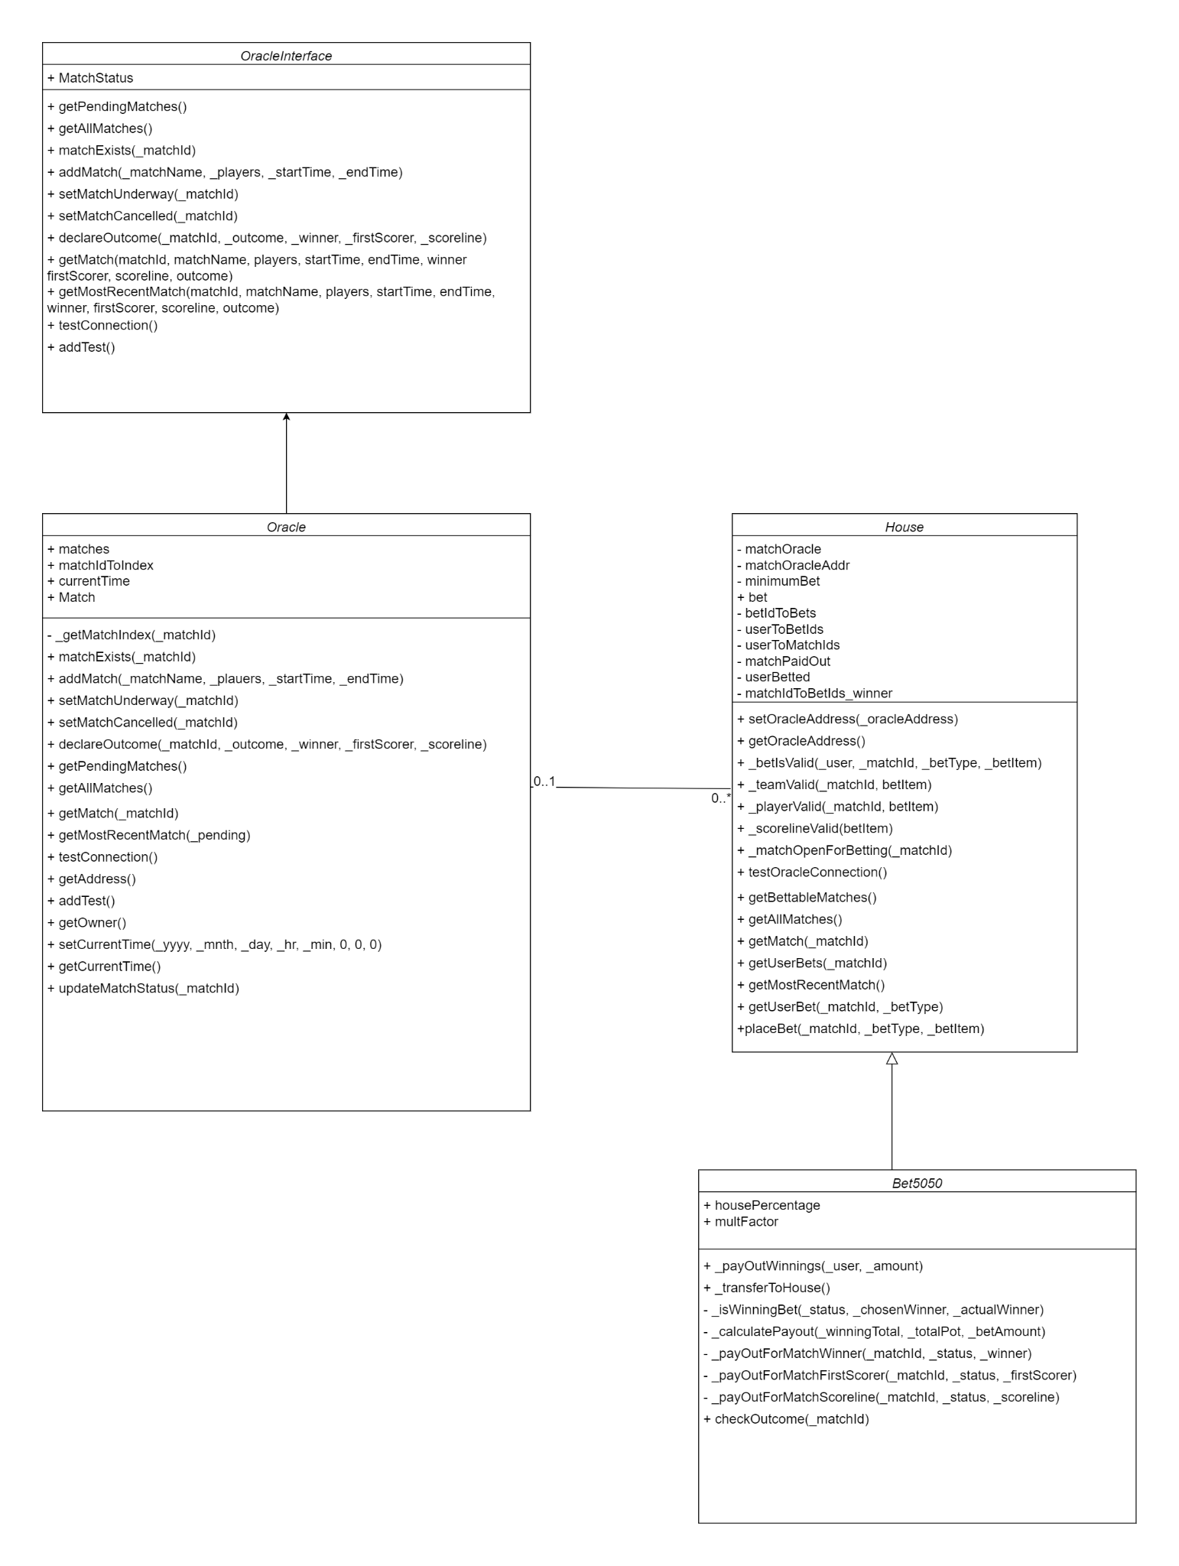

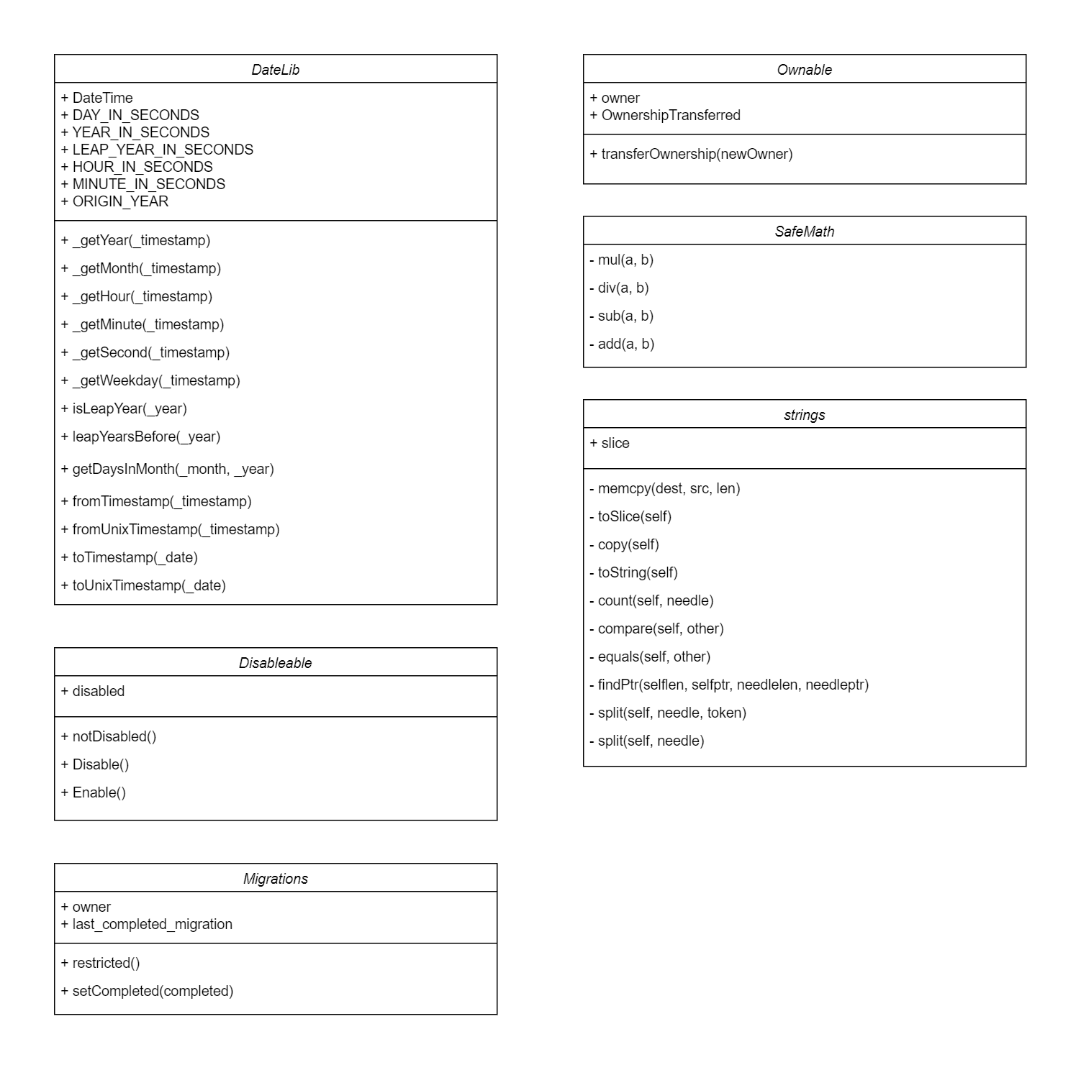

## 

## **2.2 Elaboration of how the system works**

***2.2.1 Flow Diagram***

The flow diagram below showcases the dynamics that occur between a single bettor and the underlying contracts governing the proposed betting system.

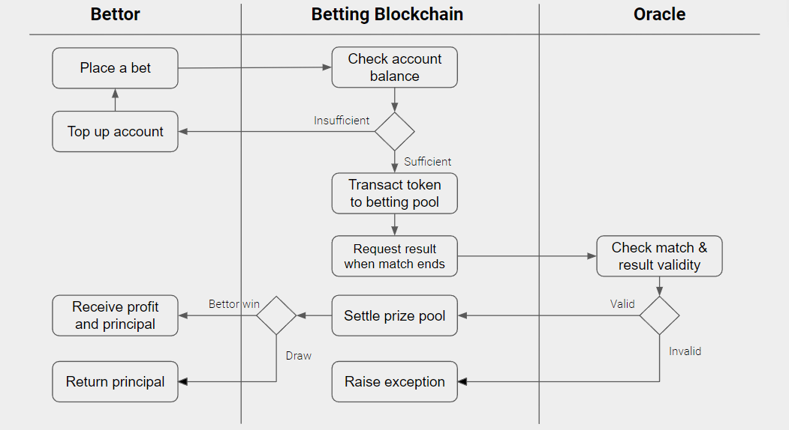

***2.2.2 Betting Features***

The main feature that our product offers is the ability to bet. There are plenty of betting types being offered out there in the sports betting world. Our team narrowed down the coverage of betting types on a particular match to the following based on its popularity and how easy it is for a hypothetical Oracle to verify results:

1. Winner – between two opposing teams, who the final winner is.
2. Scoreline – between two opposing teams, what is the final scoreline (order matters and you need to bet on the exact scoreline to win).
3. First Scorer – of all the players participating in the match from both teams, who is the player to score first.

While the match has yet to begin, these bettings have fluctuating odds, as dictated by demand for a betting choice. In other words, the Ethereum weights of each possible betting choice in each betting type determine the odds. Once the match starts, no more bets will be accepted by the contract, thus these odds can no longer change. At the end of the match, depending on the match results and the odds, the appropriate payouts are delivered to the bettors.

***2.2.3 Helper Features***

There are other helper features available to bettors. Betting is an inherently risky venture for any bettor since it involves money (cryptocurrency in this case). Thus, it is incredibly important that a bettor is able to receive relevant information in order to make the most informed decision. The team expects that the following features will be most appreciated by bettors:

1. Query the matches available for betting. This is important to the bettor because it displays the range of matches that are available for betting. Bettors are given the awareness and freedom to choose a match they are most confident in winning a bet. Additionally, bettors can also diversify their betting risk by allocating their funds to different matches, thereby lowering their risk exposure.
2. Query past match results. This could be particularly interesting for bettors who wish to use historical data to predict outcomes for upcoming matches. The mathematical bettors will especially appreciate this feature because they will be able to conveniently obtain accurate data to make probability based decisions. To people who might want to use discretion to make betting decisions, this is more of a bonus function that enables bettors to gain past information within the same Bet5050 ecosystem.
3. Check current odds. Even though betting odds will be constantly changing before a match commences, the ability to calculate present odds will be a heavily used function. This is because people can get some inkling of how risky their bet is. From there, they can have an idea of potential payouts of a given bet. Based on the information returned, bettors can also choose to adjust their bet to suit their risk appetite.
4. Check current bets. As with the previous function, this allows people to understand how risky their bet is. Based on the information returned, bettors can customize their bets appropriate to their risk appetite.

***2.2.4 Oracle’s Role***

The Oracle contract plays an important role in all of this. First off, the Oracle pushes data regarding upcoming and past matches onto the Ethereum blockchain. Without this, bettors will not know what options are available to them for betting. Further, once a match ends, the Oracle relays important match results that determine the appropriate payout procedure.

Therefore, throughout the lifecycle of a match registered in the blockchain, the Oracle is responsible for updating its information (e.g. player names, startTime, scoreline) and its status (Pending, Underway, Draw, Decided, Canceled).

In this project, we are making heavy assumptions that the Oracle is a working entity built upon the ethics of decentralization. Therefore, in our implementation, we have an OracleInterface contract acting as the blueprint for any hypothetical Oracle to interact with the Bet5050 contract.

***2.2.5 Design***

We emphasize the order of the betting procedure using a comprehensive example match between Team A and Team B.

Pre-Match Phase:

1. Oracle contract sends information about an upcoming match to the Bet5050 contract. Information includes things like teams involved (Team A, Team B), players of each team (PlayerA1, PlayerA2, … PlayerB10, PlayerB11), start datetime of the match, etc. This information is relayed to the bettors.
2. Bet5050 contract initializes 3 independent pools for this match, each corresponding to one betting type (Winner, Scoreline, First Scorer).
3. Bettors use a combination of helper functions, research and discretion to freely choose which betting type to buy into (Winner, Scoreline, First Scorer), the betting choice (e.g. Winner: Team A), and how much Ethereum to bet. The funds to cover the bet is in the placeBet() function.
4. Right up to the point where the match commences, as more bettors fund the pool, the weightage of each betting choice in each pool is changing.

Match Phase:

1. Any placeBet() functions are rejected, hence the odds are fixed. Bettors can view their odds and bets but they are not allowed to adjust it. Only the match result can determine their payout.

Post-Match Phase:

1. If the betting type’s outcome is a draw (i.e. Winner: Draw, First Scorer: No Goals), then all bets for that betting type are refunded.
2. If the betting type’s outcome has a winner, (i.e. Winner: Team A, Scoreline: 1-0, First Scorer: PlayerA1), then the losers of the bet loses all their bet amount while the winners of the bet receive a payout proportional to the size of their bet.

***2.2.6 Betting Pool Mechanics***

Let us consider a match between Team A and Team B. The pool (for betting type Winner) is initialized with 0 ETH.

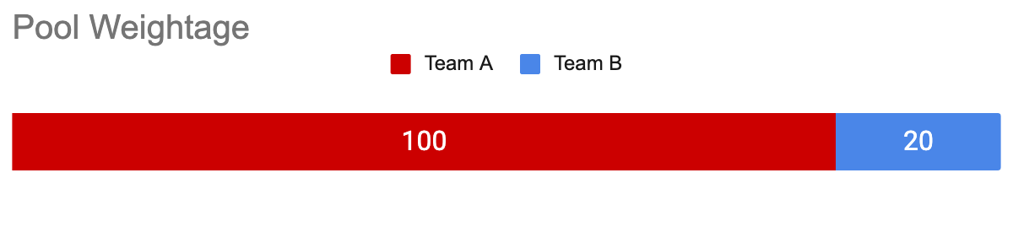

5 people bet 20 ETH each on Team A while 2 people bet 10 ETH each on Team B. The pool has a total of 120 ETH, and the odds of Team A:Team B is 100:20 = 5:1. Note that profit does not include a bettor’s original bet amount.

* If Team A wins, the 5 people split 20/5 (4 ETH each in profit). Each of them profit ⅕ times their original bet.
* If Team B wins, the 2 people split 100/2 (50 ETH each in profit). Each of them profit 5 times their original bet.

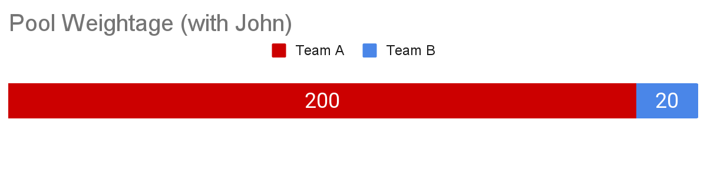

If John decides to bet 100 ETH on Team A, the pool is now worth 120+100 = 220 ETH. The odds have dynamically changed for Team A:Team B to 200:20 = 10:1.

* If Team A wins, the winning pool is 20 ETH.
  + John’s profit = 20 x his original bet = 20 x 100/200 = 10 ETH
  + Each other individual Team A bettor’s profit = 20 x 20/200 = 2 ETH
* If Team B wins, the winning pool is 200 ETH.
  + Each individual Team B bettor’s profit = 200 x 10/20 = 100 ETH

The above betting pool mechanism applies also to First Scorer and Scoreline, though includes more entities in the pool for the other two. For instance, the First Scorer betting pool can have at least 22 entities (players) for an 11v11 football match. Therefore, for each match, 3 betting pool mechanisms occur simultaneously but independently from one another.

***2.2.7 Rationale***

There are a couple of reasons as to why we chose this set of features and designs. Firstly, this implementation ensures that the odds are not being set by a pool maker. In legacy sports betting, bookmakers set the odds and profit off the margins. For example, If the real odds are Team A -190 vs Team B +160. A bettor would need to bet $190 on Team A to win $100 or $100 on Team B to win $160. But many bookkeepers would set the odds at -200 to 150, and earn the difference as commission. Instead, odds are based on real-time betting demand before a particular game. Therefore, odds are reflective of the collective bettors’ sentiment and not on greed.

Secondly, the betting process is entirely transparent. Every bettor understands how the odds are being determined, and this is verifiable in the publicly available blockchain. What’s more, we provide to the bettors a comprehensive suite of tools to easily make their own betting decisions. This gives power to the bettors in deciding odds.

Finally, the mechanics of the betting system is incredibly novel. This is exciting and attractive to current bettors who wish to be involved with something so technologically advanced while feeding their desire to bet. This interesting approach can also inspire the public to research, discover and implement more unique applications in the dapps space. Thus, it is our goal to upend the sports betting industry while inspiring innovation.

# **3. Analysis**

## **3.1 Desirable features**

***3.1.1 Fair Odds***

The chief reason why we pursued this project is to challenge the betting market being controlled by bookmakers. We see too many opportunities for predatory bookmakers to take advantage of bettors and we hope to weed them out. Especially as the betting market gets larger and digitisation efforts make it easier to access betting, this has the potential to be a major societal issue. We simply want to change a system where odds can sometimes be so informally determined and to make transactions more standardized. This not only means that the odds structure must be clearly outlined, but also that payouts are undeniably correct.

***3.1.2 Track Positions***

Due to the nature of the proposed betting system where odds are fluctuating before a match’s commencement, we expect and understand that bettors will want to track their positions. There should be a convenient function for bettors to track both a match’s odds and their own bets. With these two data points, bettors will be able to react by amending their stakes in the betting pool.

***3.1.3 Betting Type Variety***

Bettors will be enticed that a betting system boasts the ability to bet on a huge range of betting types. A comprehensive variety of betting types enables people to explore what they would like to bet on. Bettors want this variety because it gives them the freedom of choice to determine their risk/reward. This also helps with aggregation to a single platform where bettors can access functions for all their betting needs.

***3.1.4 Search Engine Capabilities***

While it is nice to cater to the important betting functions, the system must also be able to connect the bettors and matches. The system must act as a marketplace, where bettors can browse from a catalog of betting options so they are always aware of upcoming betting events. On top of that, it also improves user experience. A robust search engine is one where the bettor is able to filter down to a subset of prospective matches to bet on.

***3.1.5 Amend Bets***

A betting system where bettors are able to increase or decrease their exposure to a particular bet before a match commences can be valuable. Increasing bets is not much of a problem in legacy sports betting. However, for decreasing bets, it is entirely dependent on the bookmaker to approve a bet withdrawal or not. This uncertainty is undesirable for bettors because it is an additional risk that is outside of the bet’s risk itself. Most bettors would much prefer the option to withdraw their bets with no questions asked. In a bet, it is very understandable that bettors would have the urge to withdraw their bets (due to unsatisfactory odds, shifting betting risk, changes in match predictions, etc. ). Giving bettors the choice to customize their bets on the fly is very empowering to them. Again, this system is all about handing power over from bookmakers to the bettors.

***3.1.6 Betting Tokens***

A desirable betting system is one where bettors can use a highly established virtual currency to execute their betting functions and to receive payouts. We envision an infrastructure where bettors can exchange ETH for BetTokens in order to carry out these transactions. BetTokens will therefore represent the value of stake that goes into a particular pool. The prevalence of people utilizing these BetTokens represents the degree of penetration of this product into the betting market because people utilize it. The value of BetTokens comes from aiding bettors to call useful services in the betting system, and being a reward for bet payouts. Further, the existence of BetTokens will become a natural marketing tool to entice more people to become involved in this newly formed virtual currency economy.

***3.1.7 Trusted Oracle***

This is perhaps one of the most important aspects of the proposal that can make or break the betting system. In our betting system, we rely heavily on extrinsic information from the real world – the first being pre-match information and the second being match outcomes. If we are not able to ensure that information from the oracle is decentralized, bettors will feel that their bettings are of illegitimate matches. Further, bettors may also dispute their match payouts as smart contracts execute based on unreliable information.

## **3.2 Bet5050 features**

| **Desirable features** | **Bet5050 features** | **Extent** |
| --- | --- | --- |
| Fair Odds | Yes | There is nothing predatory about our current implementation. Odds are purely determined by bettors’ speculation, resulting in a fair betting process.  The entire betting infrastructure is also publicly available, so there is no conflict that the bets are unfair or that payouts have not been done. |
| Track Positions | To an Extent | Bet5050 provides the feature to get bet information of an already betted bet callable by using getUserBet(). Bettors will be able to react by amending their stakes in the betting pool. |
| Betting Type Variety | To an Extent | We provide three betting types for bettors to be involved in, one of Winner, Scoreline, or First Scorer. These three betting types are what the team narrowed down to be the most popular betting types, hence we expect that it will be able to cater its demand.  However, we also recognize that to capture more of the betting market, we will need to be more creative with more betting types. |
| Search Engine Capabilities | To an Extent | We have implemented some handy functions for bettors to search for matches of interest. Particularly, bettors can check up on all matches (including past matches), upcoming matches and the most recently added match. This can be done using getAllMatches(), getPendingMatches() and getMostRecentMatch().  The first function caters to bettors because they could use it to verify that the Oracle’s past information had been accurate or not. Further, bettors may want to use historical data for their predictions. The second function caters to bettors because they can get a comprehensive understanding of their subsequent potential bets. Finally, bettors can use the last function to query what the most recently added match is.  Ultimately, bettors are able to discover and connect to preferred matches. |
| Amend Bets | To an Extent | Through Bet5050, bettors are allowed to increase the size of a previously placed bet using the placeBet() function. This enables them to increase their stake, hence risk exposure to the bet.  We recognize that withdrawing a bet is important as well. It is a similar action to rebalancing a portfolio in the financial market and we need to be able to offer this option. |

## **3.3 Building towards desirable features**

| **Desirable features** | **Bet5050 features** | **Improvement** |
| --- | --- | --- |
| Track Positions | To an extent | Due to time constraints, we were unable to implement a proper function (e.g. getOdds()) to return odds for a particular pool. However, our team believes that this function is fairly easily derived from referencing the pool variables in the Bet5050 contract. |
| Betting Type Variety | To an Extent | The aim of increasing the variety of betting types is to cater to every bettor’s demand in the market. Even more betting types for the users such as the time of first goal, which player gets the most yellow cards, more sports, etc. are some ideas that we had but did not implement.  The betting mechanics can also be changed to allow for in-game betting where instead of a hard cutoff point in time before the match starts, bettors are allowed to bet while the game is ongoing. Odds will therefore be changing over the course of the game, making betting more exciting and dynamic.  The implementation of these features depends largely on the bettors’ continued use of the product. When this occurs, our developers will be able to understand the betting types that bettors have demand for and can shift resources to developing them. |
| Search Engine Capabilities | To an Extent | Our current implementation is still fairly basic. There may come a point in time where there is such a wide variety of matches and betting types to choose from that our search function will not be robust enough.  Perhaps we could integrate some machine learning capabilities in the Bet5050 backend to have a recommendation system to serve bettors. This makes searches less manual and more personalized.  The biggest obstacle here would be time and resources. A recommendation system and expanded search functions will take much effort to build up. It would probably be a worthwhile effort since the user experience is greatly enhanced. |
| Amend Bets | To an Extent | The ability to withdraw bets goes hand in hand with the ability to increase the bet size of previously placed bets. Time and prioritizing more critical functions were the factors affecting our decision to hold off on this function. However, we do not expect that it would be a very complex function to implement. |
| Betting Tokens | No | We had not implemented this feature because we felt that we needed to get the betting functions working first. If the betting functions were able to work well with Ethereum, we do not think that there would be major issues in integrating BetTokens in the future. What’s more, the ERC20 standard makes it fairly easy to create virtual currencies outside of Ethereum.  It is also our opinion that in the early phases, bettors would not want to use BetTokens to carry out their transactions since the value of BetTokens are not clearly established compared to ETH. Only through further bettor adoption, expansion of the service and trust in the blockchain do we consider the BetToken feature to become more important. |
| Trusted Oracle | No | Even in the present, there is no established framework for creating a trusted Oracle. As mentioned, this feature makes or breaks this betting system. This project works under the assumption that there one day may be a good proxy to a trusted Oracle.  However, there may be some promising solutions. The ASTRAEA system is an Oracle that decides the truth value of Boolean propositions. In our betting system, our Oracle has two important roles of relaying pre-match information and match outcomes. The voting-based dynamic between submitters, voters and certifiers to validate Boolean propositions is appropriate because the information required is simple, does not require domain expertise and is easily verifiable. Therefore, the ASTRAEA system can be the framework used to act as Bet5050’s Oracle entity. |

## **3.4 Future**

We have gone through how Bet5050 can evolve given more resources. Our team has also thought of how we can expand on these features to make the product sustainable and enticing in the long term.

***3.4.1 Betting Circles***

Instead of betting with all participating bettors in Bet5050, we create betting pools for different social circles. Thus, for a match, there can be multiple betting types and within each betting type, instead of one common pool, there can be multiple betting pools accommodating different social circles. In other words, social circles will have to register as a group to create private betting pools for a match of a certain betting type. This way, money is always kept within private social circles. It is not uncommon to hear of people betting among their friends and we believe that this implementation can cater to that casual, more recreational audience.

***3.4.2 BetToken Market***

While one of our initial desirable features was to have BetTokens facilitate transactions, we also want to show support to bettors who use them. A BetToken Market can be an entire contract on its own to facilitate trading of BetTokens into other virtual assets of value. It forms a way for users to buy into the BetToken economy and to sell their BetToken payouts. This makes the token more valuable because we are providing a means for one to easily trade it for other assets. It also gains trust for BetTokens because of how liquid of an asset it can be.

***3.4.3 Discussion Forums***

Having some form of discussion forum where bettors can discuss bet predictions and share betting strategies, much like Reddit’s WallStreetBets forum would be an interesting venture. To bettors, it makes the experience more social and interactive. It is also helpful for developers as they will be able to interact with the community, to understand the demand for certain features and to cultivate a welcoming community. Thus, the communication between bettors and developers is enhanced.